Sierpinski Gaskett Graphic Documentation
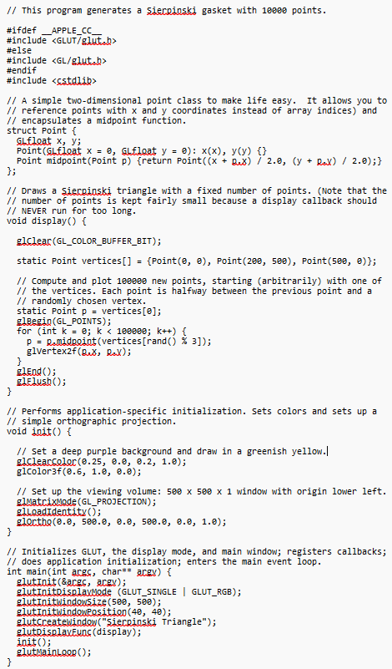
2D Sierpinski code
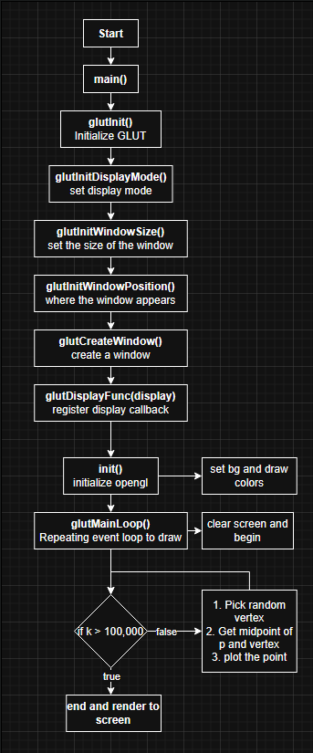
2D Sierpinski code logic flowchart
Compiling project1 Sierpinski C++ file

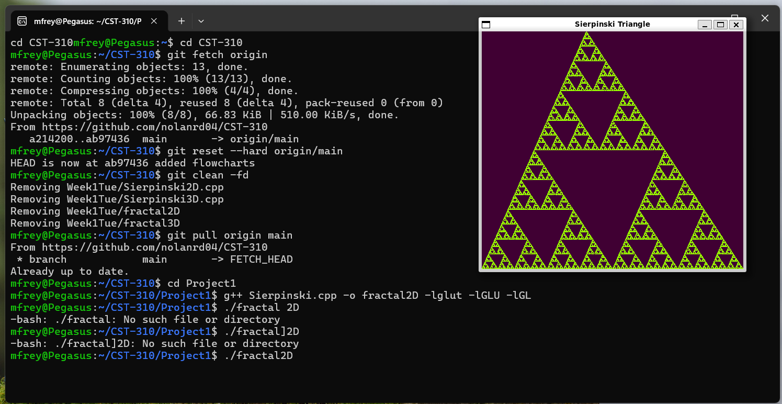
Running compiled Sierpinski 2D program and resulting image output
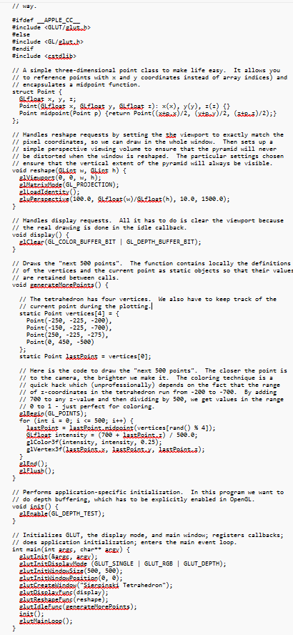
3D Sierpinski code
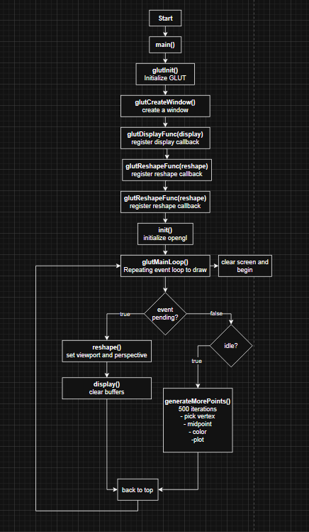
3D Sierpinski code logic flowchart
Compiling project1 3D Sierpinski C++ file
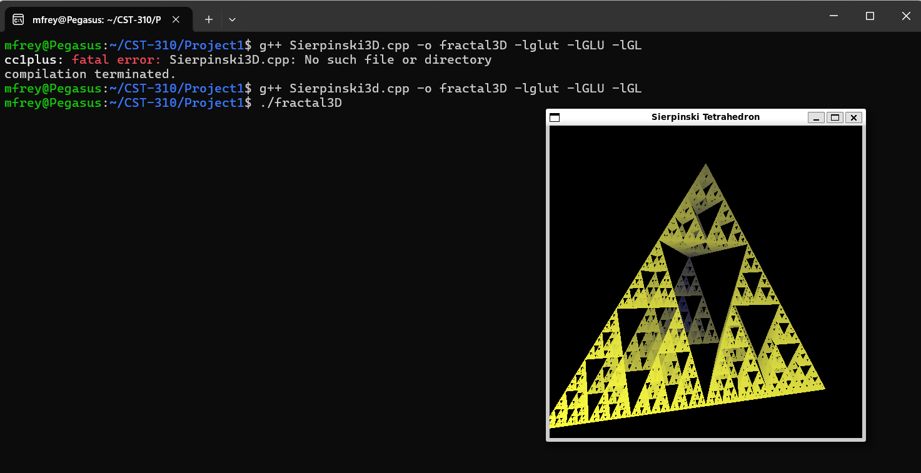
Running compiled Sierpinski 3D program and resulting image output

Git Hub link:
https://github.com/nolanrd04/CST-310.git

